
The Center for Plant Science Innovation is an interdisciplinary research and training program in the basic plant sciences at the University of Nebraska-Lincoln. Outstanding research facilities and an interdisciplinary graduate program complement an excellent group of faculty with research strengths in several areas of plant biology research.
Faculty research emphases include plant-microbe interactions, plant signaling and organellar biology, abiotic and biotic stress responses, and genomics/proteomics. The George W. Beadle Center for Genetics Research affords state of the art research facilities and an array of core facilities, including proteomics, genomics, plant transformation, microscopy, bioinfomatics and flow cytometry, to provide student and postdoctoral trainees with a phenomenal environment in which to conduct research.
The plant research community at UNL allows for a host of productive collaborations and outstanding postdoctoral opportunities. These include plant breeding programs that incorporate modern technologies for crop improvement, an excellent ecology and evolution group that integrates an understanding of plant function to their natural environment, and an array of faculty investigating the food safety, environmental impact, and economic implications of agricultural biotechnology.
Events
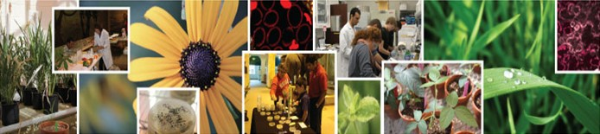
Sunday with a Scientist
Researchers from the UNL Center for Plant Science Innovation participated in the Nebraska State Museum's Sunday with a Scientist program, exploring plant science. The program, "Feeding the World in the 21st Century," provided hands-on activities to help explain the important role of plant science in addressing the world’s food demands.
2011 Plant Science Symposium
The 2011 Plant Science Symposium was held October 14 at the Sheldon Museum of Art on the University of Nebraska-Lincoln campus. Attendees enjoyed a day filled with renowned plant experts and discussion on plant signaling in response to abiotic & biotic stress.
Students Get Hands-On Experience in Plant Science
The Center for Plant Science Innovation welcomed science students from Lincoln East High School. During the visit, students participated in lab activities focused on biochemistry, plant breeding and genetics, and plant biology. Activities included extracting and purifying plant lipids, extracting DNA from soybean leaves, and learning about gel electrophoresis. Laboratories participating in this event include: Clemente Lab, Cahoon Lab, Stone Lab, Alfano Lab, and Harris Lab.
2012 ASPB Midwestern Meeting
The University of Nebraska-Lincoln hosted the American Society of Plant Biologists (ASPB) Midwest Section meeting March 24-25, 2012. Founded in 1924, the American Society of Plant Biologists promotes the growth and development of plant biology, encourages and publishes research in plant biology, and promotes the interests and growth of plant scientists in general. Membership spans six continents, and members work in such diverse areas as academia, government laboratories, and industrial and commercial environments. The Society also has a large student membership. ASPB plays a key role in uniting the international plant science disciplines.
Contact
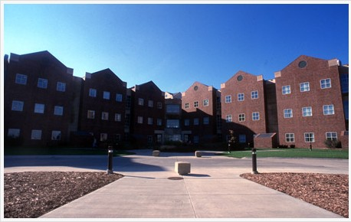
Center for Plant Science Innovation

N300 Beadle Center
1901 Vine Street
Lincoln, NE 68588
Phone: 402-472-2635
Fax: 402-472-3139
Email:BiotechPSIOffice@unl.edu
Hours: 8 a.m. - 5 p.m. Monday-Friday

